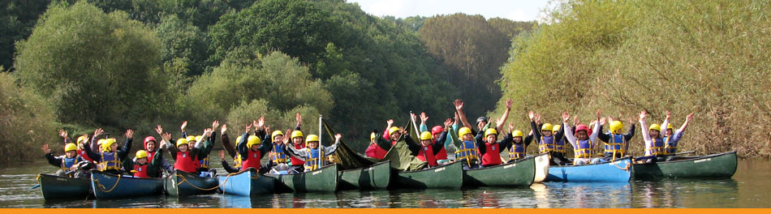
September 2019

Dear Parents,

We have organised a Year 6 residential visit to Viney Hill Christian Adventure Centre in the Forest of Dean for the week commencing 22nd June 2020.
This visit has distinct differences from the Year 4 visit which are:

-The children will be camping at the centre using static tents rather than staying in the built accommodation.
-They will follow a completely different programme of activities from that of Year 4, some of these will take place away from the Viney Hill site and will be age-appropriate.

One class will go from Monday – Wednesday and the other class will go from Wednesday to Friday. We will let you know the exact date for each class nearer the time.

Classes will leave school on either Monday or Wednesday morning with a packed lunch and arrive at the centre in time for activities in the afternoon. The children will return to school after lunch on either Wednesday or Friday.

We are sure that all of the children would really enjoy this opportunity and benefit tremendously from the activities that the centre organises. All staff and children who visited the centre feel confident that the facilities and staffing are a high standard. The centre is licensed for Adventure Activities with the AALA However, full approval from Birmingham Local Authority is also required to enable this visit to go ahead.

The cost per pupil is £200 (based on 25 children per group). This includes transport, insurance, 2 nights full board, lodging and all activities.

We would appreciate being able to collect deposits of £50 by Monday 8th November 2019 so that we can plan pupil numbers. Any remaining balance will be due by Friday 8th May 2020 and payments by instalments can be made on line. Parents who claim Income Support, Income Based Jobseekers Allowance or Child Tax Credit (provided they are not entitled to Working Tax Credit) and have an annual income, as assessed by the Inland Revenue, that does not exceed £16,190 are entitled to a reduction for board and lodgings. If you would like to discuss this further, please see Mr Smith or Mrs Price.

We will be holding a meeting for parents on Thursday 7th November 2019 at 3.30pm for the opportunity for any questions you may have. However, if you would like to book a place for your child in advance of this, please complete and return the form below. Please note that deposits are non-refundable.

Yours sincerely

Mr S Smith
Head Teacher

-----------------------------------------------------------------------------------------------------------------------------------
Year 6 Viney Hill Christian Adventure Centre 22-24 or 24-26 June 2020

I give permission for my child……………………………………………………..Class................................... to go on the residential visit to Viney Hill Adventure Centre in June 2020 and enclose a £50 deposit.

Signed ……………………………………………………………………..Parent/Guardian
Please make cheques payable to BCC General Fund Revenue or pay using school money www.eduspot.co.uk

