June 2017
Dear Parents,
Organisation of current Year 2 classes in Year 3 (2017-2018)
I am writing to inform you that we will be reorganising the current class groupings for our Year 2 pupils in the coming weeks. This means that from the beginning of Year 3, the children will be in new groupings.
When we allocate children to classes before admission, we seek to achieve a balance of pupils’ characteristics in terms of gender, month of birth, ability and so on. However, as the year group have progressed through the school, this balance has not been maintained due to pupil mobility.
The curriculum in Year 3 is a very demanding one and it is vital that all children get off to the best possible start in September. These changes mean that the staff will be able to target their teaching with the precision and depth required for the Key Stage 2 curriculum and the children will quickly acquire the skills that they need to support continued progress.
We will consider a range of information when composing the new classes and we would value your input on this. Your child will have built friendships within their class and across the year group in recent years and we would like to give you the opportunity to provide names of children who fall into this category for your child. This will enable us to consider friendship groups as part of the process and ask that you complete and return the form attached.
Yours sincerely,

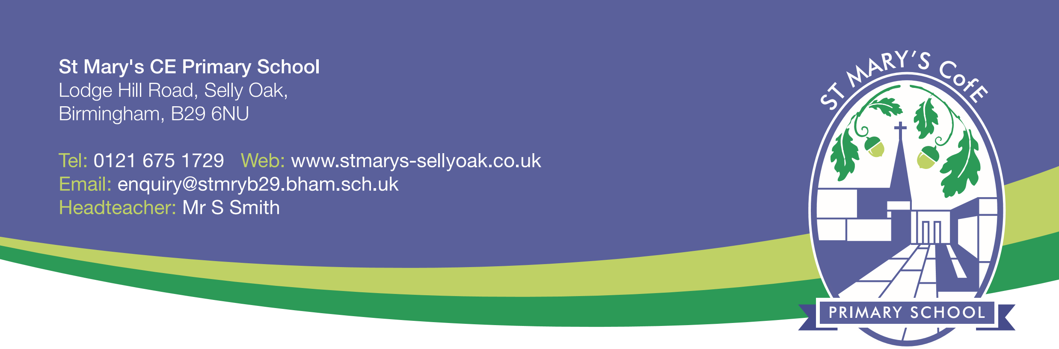
Mr S Smith
Head Teacher
St Mary’s CE Primary School

Name of Child: ............................................................... Class: .........................................

My child has built good friendships with the following children:

