June 2017
Dear Parents,
Organisation of current Reception classes in Year 1 (2017-2018)
I am writing to inform you that we will be reorganising the current class groupings for our Reception pupils in the coming weeks. This means that from the beginning of Year One, the children will be in new groupings.
The decision has been taken following a year of us getting to know your children, their needs and observing the progress they have made since joining us. There is a considerable jump in expectation between the Reception and Year One curriculum and these changes are designed to ensure that every child gets the best possible start to their journey through Year One and Year Two.
We will consider a range of information when composing the new classes and we would value your input on this. Your child will have made a lot of friendships during their first year at school and we would be grateful if you could provide the names of children who fall into this category for your child. This will enable us to consider friendship groups as part of the process and ask that you complete and return the form below.
We believe this strategy will benefit each and every child well and we look forward to seeing them build on their successes next year.

Yours sincerely,

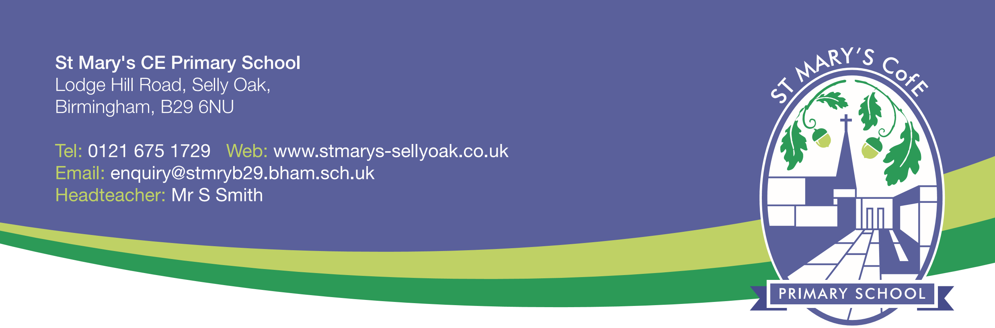
Mr S Smith
Head Teacher
St Mary’s CE Primary School

Name of Child: ............................................................... Class: .........................................

My child has built good friendships with the following children:

