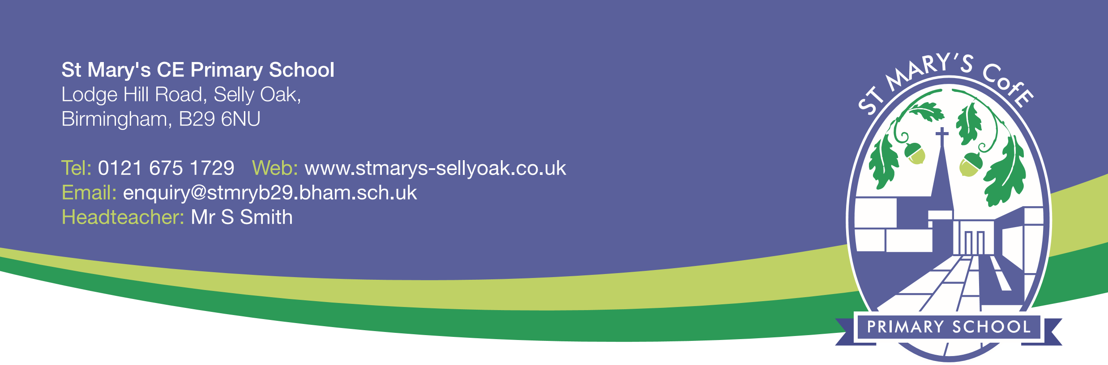
28th June 2017

Dear Parents,
In your child's book bag today you will find a leaflet about the scholastic Book Club which features a wide range of book titles many of them significantly discounted. If you would like to order any of the books please fill in the details on the back of the form and send cash or a cheque made payable to "Scholastic Book Clubs". The closing date for orders is WEDNESDAY 5th July 2017.
You can also order direct online and see the wider range of books and discounts.
Please go to http://schools.scholastic.co.uk/st-marys-b29 to browse the latest books and order online.
For every £1 you spend on this month’s Book Club, our school will earn 20p in Scholastic Rewards.
Please place your order online by July 5th, 2017.

Thank you for your support.

Mrs Peat
School Librarian

