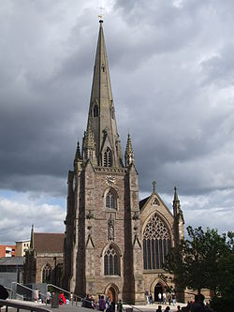
CLASS 6 LEAVERS SERVICE AT ST MARTIN’S CHURCH– Tuesday 4th July 2017

Dear Parents

We shall be taking Year 6 to St Martin’s Church for a Leavers Service on Tuesday 4th July 2017 which starts at 1.15pm. St Mary’s will join with other Birmingham schools in order to celebrate their achievements during the Primary School years and also to think about the next steps in their lives.

Children will have an early lunch and we shall then leave school and travel by bus. We shall return in time for the end of the school day.

I am aware that you may have concerns about the children visiting a heavily populated area in the light of recent events in London and Manchester. I would like to assure you that we have planned the logistics of the visit using current guidance from Birmingham Local Authority, the police and the Diocese of Birmingham and that myself and Mr Warland will be accompanying the class along with Mr Tromans.

School uniform and suitable footwear will be required and coat/raincoat if necessary.

Please complete and return the consent form below by Wednesday 28th June.

Yours sincerely

Mr S Smith
Head Teacher

………………………………………………………………………………………………………………………………
St Mary’s CE Primary School
Class 6- St Martin’s Church Wednesday 4th July 2017

Child…………………………………………......................

I give permission for my child to go to St Martin’s Church.

Emergency Contact Number …………………………………………………………………………….......

Medical Details (if any) e, g, allergies etc. ……………………………………………………............

…………………………………………………………………………………………………………………………………

Signed……………………………………………………………………

