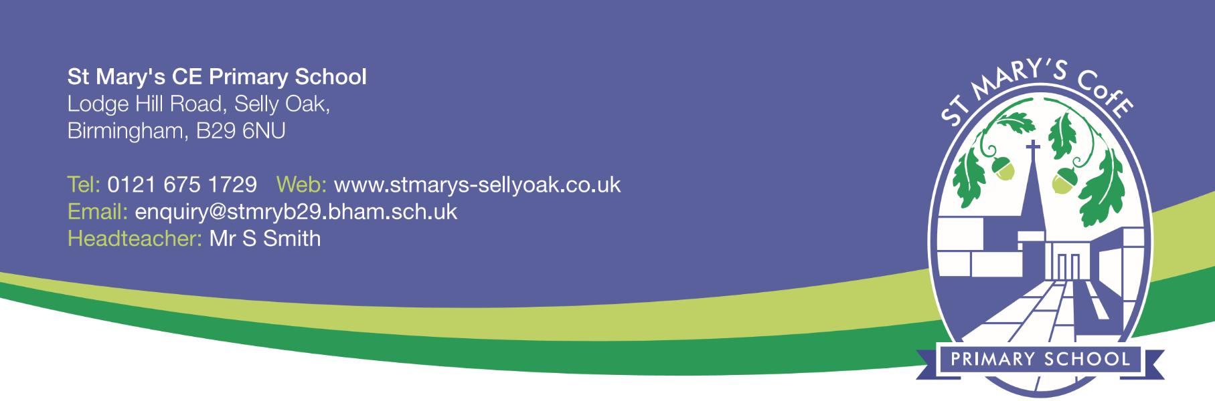6th October 2017

Dear Parent,

St Mary’s C of E Junior Choir (Years 2 & 3)

The 2016-2017 academic year saw a few changes to the Junior Choir, not least the retirement of Mrs Cater, as leader of the Choir, after many years. As a result, the choir will now be led by myself, but the choir for Year 2 and 3 will remain open to all, with no audition to take part, just the enjoyment of singing and having fun. However, spaces in the choir are limited, so please let us know if you’re interested.

The choir will start after the October half term, meeting on Wednesday lunchtimes, from 12.30 – 1.00pm, in Seals classroom.

If you would like your child to join this new choir, please fill in the form below, and return to school by Monday 16th October 2017. We will let you know before half term, if your child has a space.

Thank you for your continued support and look forward to sharing our singing with you soon.

Best wishes

Mrs C Kirby

Year 1 Seals Teaching Assistant

…………………………………………………………………………………………………………………………………………………………….

RESPONSE FOR INTEREST IN JUNIOR CHOIR

Pupil name………………………………………………………………….. Class………………………………………………………

I would like my son/daughter to attend the Junior Choir on Wednesday lunchtime.

Signature…………………………………………………………………………………. Date

Please print name ……………………………………………………………………..