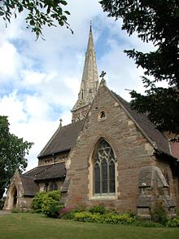
21st May 2018

Dear Parents,

Reception classes will be visiting St Mary’s Church Friday 8th June to see and experience different settings for worship in different cultures as part of our faith fortnight.

They will be walking and will leave school after morning registration and return to school for lunch.

Please complete and return the slip below no later than Tuesday 5th June.

Yours sincerely

Mrs Woods & Miss Domagala
Class Teachers

------------------------------------------------------------------------------------------------
St Mary’s CE Primary School
Year R visit to St Mary’s Church – Friday 8th June

Child…………………………………………………………. Class…………………………………………………

I give my permission for my child to participate in the visit.

Emergency contact no..................................................................................

Medical details (if any)....................................................................................

......................................................................................................................

Signed…………………………………………………………………………………………….. Parent/Guardian

