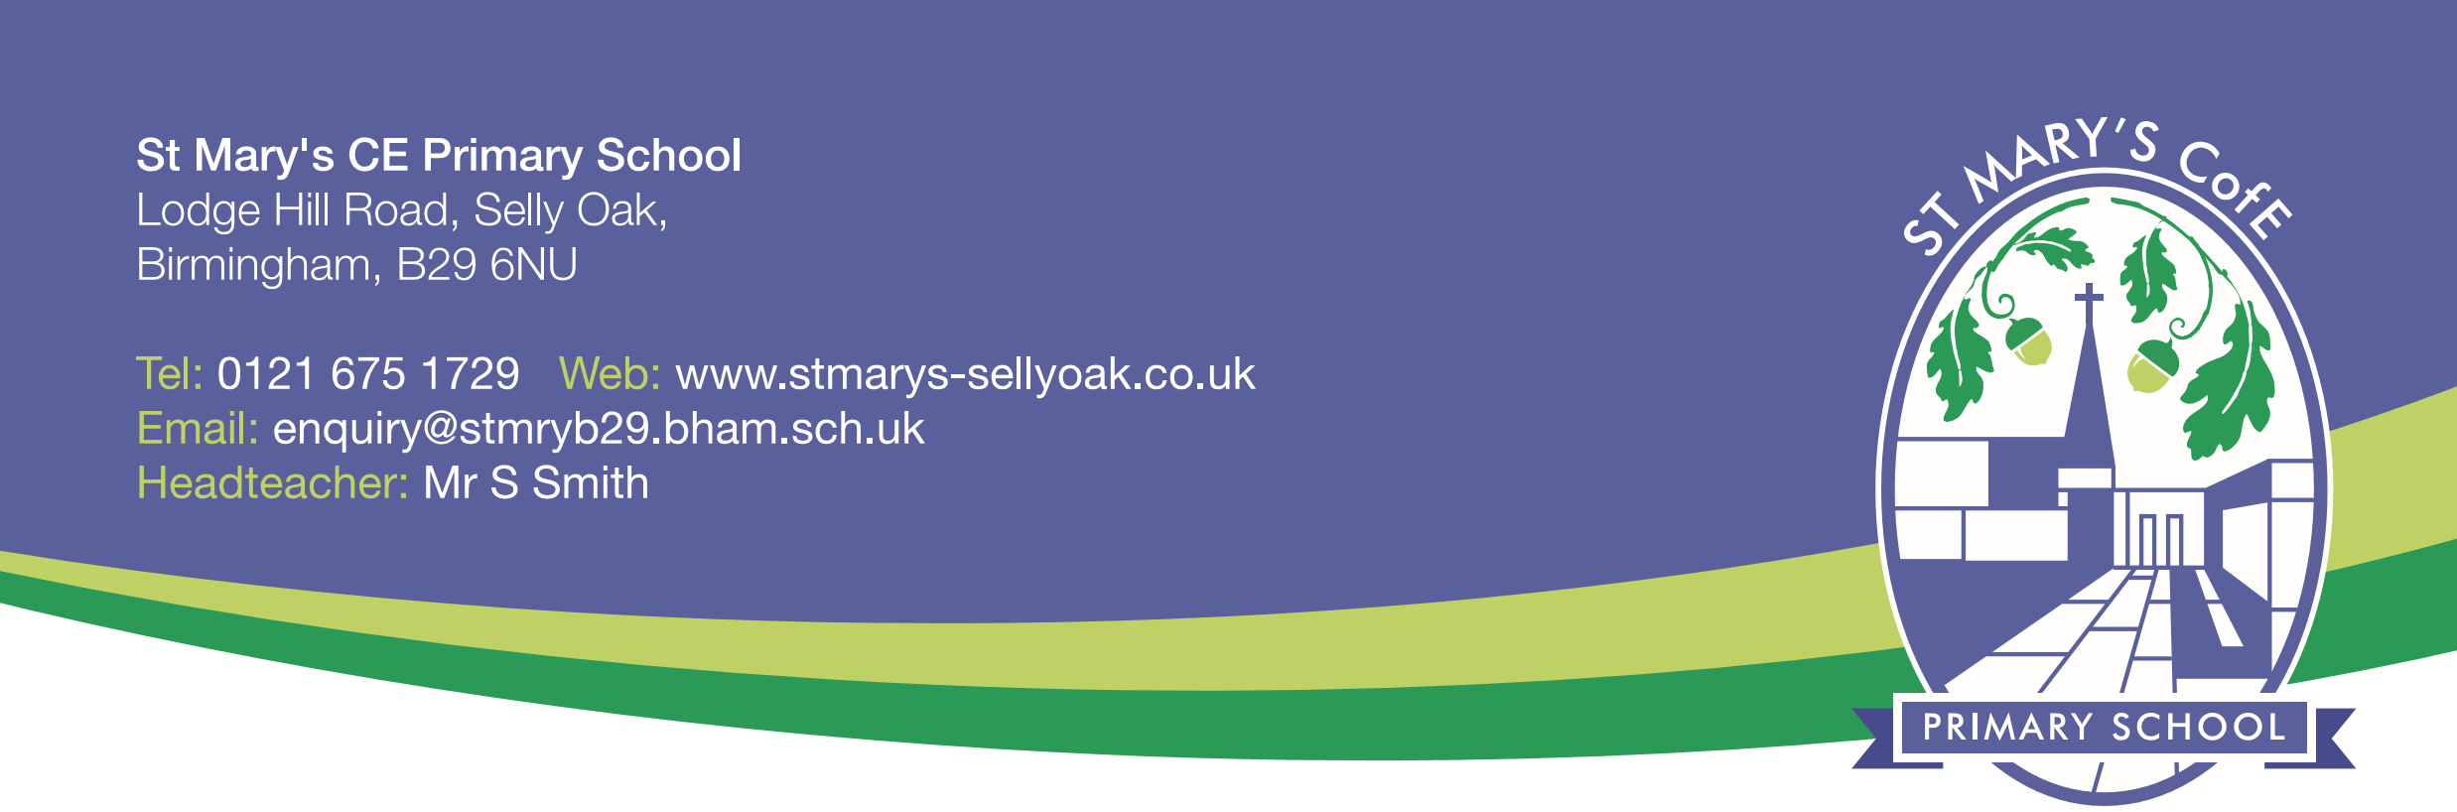30th April 2019

Dear Parents,

Since December, we have been developing links with Somerville Primary School in Small Heath with a view to giving children in both schools a greater understanding of the diversity to be found in a large multicultural and multi-faith city such as Birmingham. We selected our Year 4 pupils for this project and hope that it will signal the beginning of a long tradition of exchange visits between the two schools.

The first phase of this began last term when the children were given a pen pal to write to and the second phase will take place this term when the children will visit one another's schools along with the local place of worship to which they are linked. In our case, St Mary's Church and for Somerville, the Central Jamia Mosque Ghamkol Sharif on Golden Hillock Road in Small Heath.

We are hosting Somerville pupils next Thursday (9th May) and they will be hosting us on Thursday 27th June (further details of this visit will be given to you closer to the time). For both visits, children will be eating lunch together and they will need a packed lunch on both days to enable the visits to run as smoothly as possible.

Next Thursday's visit will involve time in school and a visit to Church followed by lunch (if the weather is good, this will be a picnic lunch on the field next to the church). Children in both schools are very excited by the prospect of meeting each other for the first time and we look forward to them sharing news of the visit with you. Permission for this visit is covered by the local visits form you have completed previously.

Many thanks for your support with this exciting project.

Yours sincerely,

Mr S Smith

Head teacher