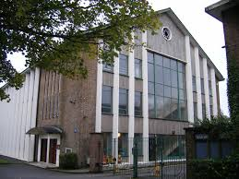
9th May 2018

Dear Parents,

Class 3Falcons will be visiting the Birmingham Central Synagogue in Birmingham on Thursday 14th June to see and experience different settings for worship in different cultures.

They will be travelling by bus and will leave school after registration at 9am and return to school for lunch at 12.30pm.

Please complete and return the slip below no later than Thursday 7th June.

Yours sincerely

Mrs Precious-Li
Class Teachers

------------------------------------------------------------------------------------------------

3 Falcons trip to Birmingham Central Synagogue– Thursday 14th June 2018

Child…………………………………………………………. Class 3 Falcons

I give my permission for my child to participate in the visit.

Emergency contact no..................................................................................

Medical details (if any)....................................................................................

......................................................................................................................

Signed…………………………………………………………………………………………….. Parent/Guardian

