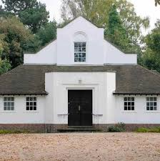
24th May 2018

Dear Parents,

Year2 will be visiting the Quakers meeting house in Selly Oak on Thursday 7th June to see and experience different settings for worship in different cultures.

They will be walking and will leave school after lunch and return to school by 3.30pm.

Please complete and return the slip below no later than Tuesday 5th June.

Yours sincerely

Mrs Fage & Miss Goley
Class Teachers

------------------------------------------------------------------------------------------------
St Mary’s CE Primary School
Year 2 visit to Quakers meeting house – Thursday 7th June

Child…………………………………………………………. Class…………………………………………………

I give my permission for my child to participate in the visit.

Emergency contact no..................................................................................

Medical details (if any)....................................................................................

......................................................................................................................

Signed…………………………………………………………………………………………….. Parent/Guardian

