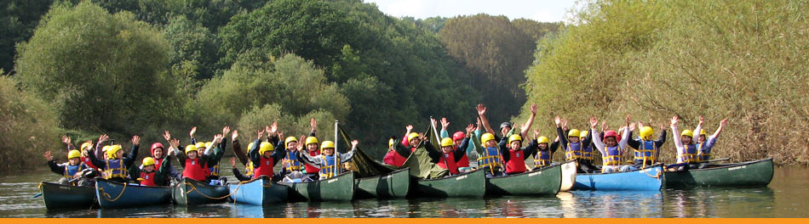
January 2018

Dear Parents

We would once again like to take our Year 4 children to the Viney Hill Christian Adventure Centre for three days and two nights in October 2018. Eagles & Falcons will have the opportunity to go during the week commencing 22nd October. This seems a long way off yet but we thought parents would appreciate as much notice as possible so that they can start making payments in instalments. (We will let you know the exact date for each class later in the year).

The centre is licensed for Adventure Activities with the AALA and offers full board accommodation.
We would leave school on Monday or Wednesday morning with a packed lunch and arrive at the centre in time for activities in the afternoon. The children would experience three additional activities during their stay and return to school after lunch on Wednesday or Friday.

We are sure that all of the children would really enjoy this opportunity and benefit tremendously from the activities that the centre organises. All staff and children who visited the centre feel confident that the facilities and staffing are a high standard. However, full approval from Birmingham Local Authority is also required to enable this visit to go ahead.

The cost per pupil is £150 (based on 25 children per group). This includes transport, insurance, 2 nights full board, lodging and all activities.

We would appreciate being able to collect deposits of £50 by Friday 16th February 2018 so that we can plan pupil numbers. The remaining amount will be due by the end of September and payments of any amount can be made at any time up to this point. Parents who claim Income Support, Income Based Jobseekers Allowance or Child Tax Credit (provided they are not entitled to Working Tax Credit) and have an annual income, as assessed by the Inland Revenue, that does not exceed £16,190 are entitled to a reduction for board and lodgings. If you would like to discuss this further, please see Mr Smith or Mrs Price.

We will be holding a brief meeting for parents on Thursday 8th February in school at 3.00pm to give further information and answer any questions. However, if you would like to book a place for your child, please complete and return the form below along with the £50 deposit to school by Friday 16th February 2018. Please note that deposits are non-refundable.

Yours sincerely

Mr S Smith
Head Teacher
-----------------------------------------------------------------------------------------------------------------------------------
Class 4 Viney Hill Christian Adventure Centre 22 – 24 or 24 – 26 October 2018

I give permission for my child……………………………………………………..Class................................... to go on the residential visit to Viney Hill Adventure Centre in October 2018 and enclose a £50 deposit.

Signed ……………………………………………………………………..Parent/Guardian
Please make cheques payable to BCC General Fund Revenue or pay using school money www.schoolmoney.co.uk

