Reception Classes

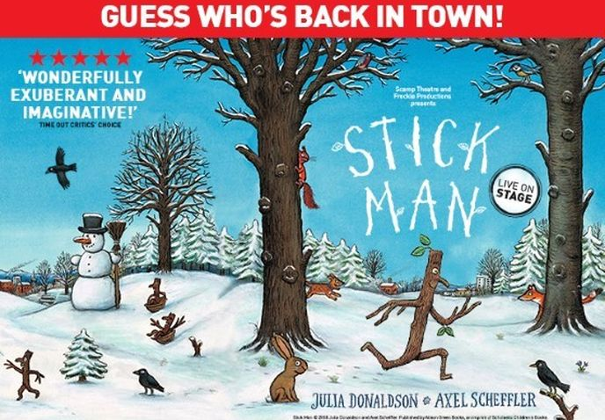
ANNUAL THEATRE TRIP
Stick Man
2nd October 2017

Dear Parents

We have organised our annual theatre visit as so many parents and children feel it is a valuable experience.

We have booked tickets to take the Reception children to see Stick Man at Birmingham Town Hall on the afternoon of Thursday 11th January 2018. The performance starts at 1.00pm therefore we shall leave school after lunch at 12.15pm and return to school at approximately 3.10pm. The cost of this visit is £16 per child. The cost is broken down as follows:

- £11.20 – ticket cost
- £4.70 - coach cost
- 10p - insurance cost

We would like to remind parents that payments of any size can be made throughout the Autumn term.

This event is an experience that is enjoyed by all who attend. The specific aims of the visit are:
- To experience a live theatre performance
- To support the children’s language development
- To strengthen the children’s social skills, e.g. through partners

The theatre performance is also followed up with cross-curricular work at school.

The 1988 Education Act and Governors’ Policy require me to make it clear that our intended visit can only take place if parents are prepared to make a voluntary contribution. There is no obligation to contribute and no child will be omitted from taking part, but it will be necessary to have substantial parental contributions for the visit to go ahead. Please do not hesitate to contact school if you have any queries.

Mr S Smith
Head Teacher
………………………………………………………………………………………………………………………………………………
CONSENT FORM FOR Theatre trip – Reception classes– Stick Man at Town Hall Birmingham 11.1.2018

Child’s Name…………………………………………………….. Class ……………………………………….
I consent to my child taking part in the visit and enclose a payment of £16

Medical Details if any:………………………………………………………………………….

Emergency contact No………………………………………………………………………

Signed………………………………………………………………………
Cheques made payable to the BCC General Fund Revenue or payment online at www.schoolmoney.co.uk

