APPLICATION FOR RECEPTION YEAR ADMISSION (CHURCH ATTENDANCE): SEPTEMBER 2023

Notes:
1. This form only requires completion if you are making an application under priority 3 of the school’s Admissions Policy (Church attendance).

2. Please ensure both section A and B are completed. The completed form must be returned to:
St Mary’s CofE Primary School, Lodge Hill Road, Selly Oak, Birmingham, B29 6NU.

3. This form alone is not sufficient for an application. You must also complete Birmingham City Council’s online Admissions Procedure for a Reception place for September 2023. This can be found at: www.birmingham.gov.uk/schooladmissions

Section A is to be completed by the parent/carer. Section B must be completed by a minister from a Church of England church. For multiple applications, a separate form must be completed for each child.

Section A

Child’s Surname: First name(s):

Date of Birth:

Parent/carer’s name(s):

Home Address:

Postcode:

Section B

I confirm that the above named child and family have attended the church(es) named below on a regular basis during the previous two years (i.e. at least twice every month)*.

Name of Church(es): Name of Minister(s):

Signature of Minister(s): Date:

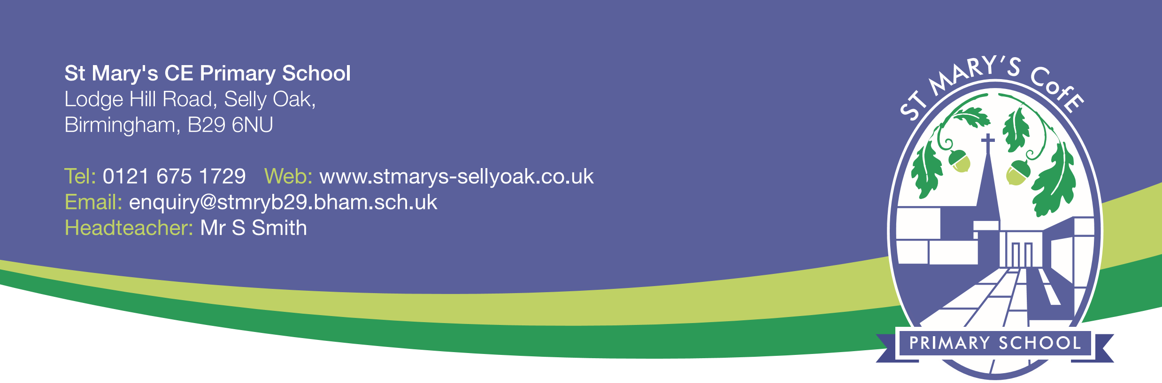
*In the event that during the period specified for attendance at worship the church has been closed for public worship and has not provided alternative premises for that worship, the requirements of these [admissions] arrangements in relation to attendance will only apply to the period when the church or alternative premises have been available for public worship”

