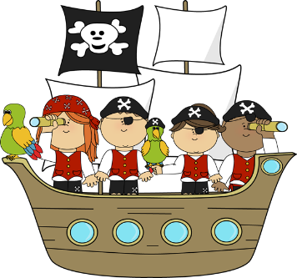
April 2017
2Robins and 2Bluebirds – Pirate Workshop – Friday 12th May

Dear Parents/Carers,
On Friday 12th May Year 2 are going to take part in an exciting pirate workshop run by story tellers Annamation.
We have a fun filled day of activities planned and our day will begin with character building and drama activities. Also during the day the children will use mapping skills to find buried treasure around school, sing sea shanties, take part in a quiz and have lots of fun learning about pirates and their daily life!
We would love to see the children in a pirate costume (if you need any dressing up ideas please speak to the staff in your child’s class).
The workshop will cost £4.50, please send in payment along with the slip below by 10th May.
Thank you
Mrs James and Mrs Dodd

PIRATE WORKSHOP – Friday 12th MAY

Child’s Name …………………………………………………………………. Class ………………………

I have enclosed £4.50 for the workshop.

Signed ………………………………………………………………………………….. Parent/Carer

