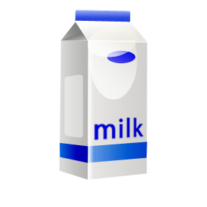
YR,1 & 2 Milk & Juice Money
& School Fund

26.02.18 – 29.03.18
Juice/Milk Money - TO BE PAID BY THURSDAY 1st MARCH
Milk money for ½ term –£5.76
Juice money for ½ term - £7.20
* YOUR CHILD WILL NOT GET A DRINK UNTIL MONEY HAS BEEN PAID *
Cheques payable to BCC General Fund Revenue or pay online www.schoolmoney.co.uk
RECEPTION CLASSES – If your child is 5 between 1st September and 29th March they will not be entitled to receive Free Milk. If you would like your child to have milk or juice for this half tem please send in payment as specified above by 1st March.
SCHOOL FUND
Half Termly payment - £1 per family or Annual payment of £6.
Cheques payable to St Mary’s School
Thank you

YR,1 & 2 Milk & Juice Money
& School Fund

26.02.18 – 29.03.18
Juice/Milk Money - TO BE PAID BY THURSDAY 1st MARCH
Milk money for ½ term –£5.76
Juice money for ½ term - £7.20
* YOUR CHILD WILL NOT GET A DRINK UNTIL MONEY HAS BEEN PAID *
Cheques payable to BCC General Fund Revenue or pay online www.schoolmoney.co.uk
RECEPTION CLASSES – If your child is 5 between 1st September and 29th March they will not be entitled to receive Free Milk. If you would like your child to have milk or juice for this half tem please send in payment as specified above by 1st March.
SCHOOL FUND
Half Termly payment - £1 per family or Annual payment of £6.
Cheques payable to St Mary’s School
Thank you

