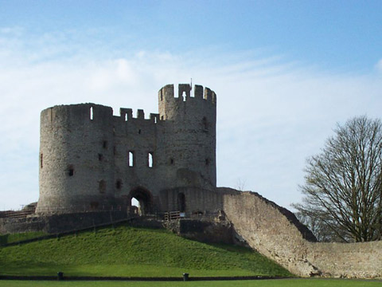


Reception classes to Dudley Castle & Zoo

April 2018

Dear Parents/carers,

We have booked a visit to the Dudley Castle and Zoo on Friday 11th May 2018 as part of our learning journey ‘Castles and Dragons’. We will leave school at 9.00am, travelling by coach and return to school by 3.30pm

- Your child will be provided with a packed lunch from school
- School uniform is to be worn
- Waterproof coat & suitable shoes for walking
- Your child will need to bring their water bottle

Due to the charges we must ask for a voluntary contribution of £15.00 towards the cost of the trip (admission £7.50, coach £7.50). The 1988 Education Act and Governors’ Policy requires us to make it clear that our intended visit can only take place if parents are prepared to make a voluntary contribution. There is no obligation to contribute and no child will be omitted from taking part, however it will be necessary to have substantial parental contributions for the visit to go ahead. If you are unable to make a contribution for whatever reason, you MUST contact Mr Smith.

Please sign and return the slip below no later than Friday 4th May.

Yours sincerely

Miss Domagala & Mrs Woods
Class Teachers
------------------------------------------------------------------------------------------------------
St Mary’s CE Primary School
Reception classes – Dudley Castle & Zoo

Child: _________________________________________ Class___________________

I do give permission for my child to take part in the visit. I enclose £15.00 towards the cost of the trip.

Emergency contact no..................................................................................

Medical details (if any)....................................................................................

Signed………………………………………………………Parent/Guardian

Please make cheques payable to: BCC General Fund Revenue or pay online:www.schoolmoney.co.uk

