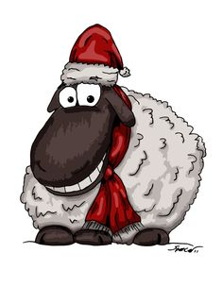
November 2016

Dear Parents and Carers
This year our KS1 (Year R, Year 1 and Year 2) Christmas Production will be “Hey Ewe”. Our main performances will be on:
Monday 12th December at 2pm
Tuesday 13th December at 9.30am and
Due to Health and Safety regulations tickets for these two shows will be restricted to TWO per family and will be issued on a first come first serve basis.
Please note parents who attend the main performances with young children will be asked to sit at the back to enable a quick and undisruptive exit if necessary.
HOWEVER, we have a dress rehearsal on:
Monday 12th December at 9.30am.
To which we invite those parents/carers who have pre-school children, grandparents and anyone unable to make the main performances.

Please indicate your preferences on the slip below and return as soon as possible. If a preference has not been indicated we will choose for you.
*School aged children will NOT be admitted without authorisation from their school.

Yours sincerely

Mr S Smith
Head Teacher

Child’s name:______________________________ Class:__________

Number of tickets:_______________

Preferred Performance:
* Monday 12th December at 9.30am DRESS REHEARSAL
* Monday 12th December at 2pm
* Tuesday 13th December at 9.30am
*Delete as applicable

Signed___________________________ Date ____________

