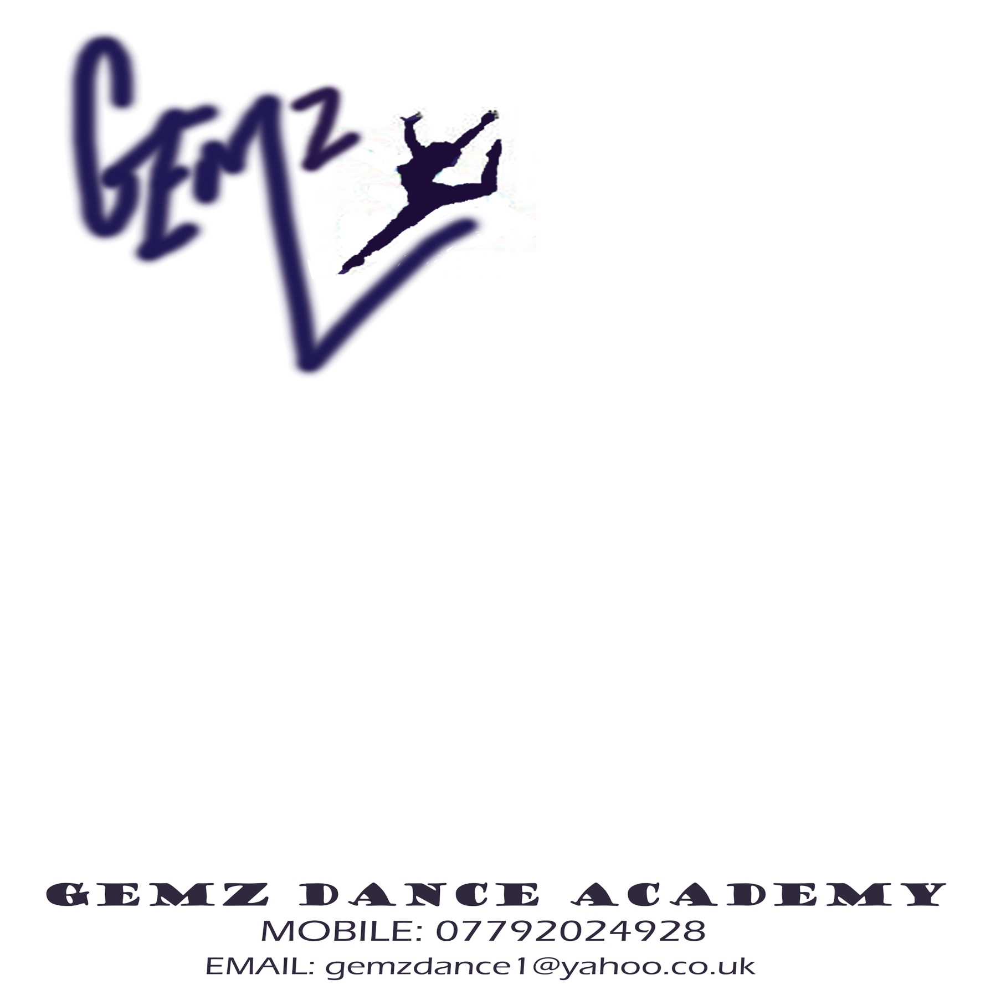
St Mary’s C of E Primary

Dance Club

Gemz Dance Academy is a fun and experienced dance company who
teach all ages and abilities.
Dance club will take place after school for 1 hour. Students will learn
all the latest moves to the most popular music including Little Mix,
Jessie J, Justin Beiber, One Direction, Lady Gaga and many more!!!
Not only do we dance but we act and sing as well so something for everyone. Gemz dance classes help students increase fitness, confidence and of course have fun with their friends. Students will also get the chance to perform, as we will be putting on many shows and performances for parents and family.

Class Info: Dance will take place in the school hall. Children will need to wear suitable clothing such as jogging bottoms, t-shirt, shorts. Something they can move easily in. Footwear can be trainers, pumps, jazz shoes or bare feet. We do have a short break in class therefore a drink is necessary but no snacks. Parents/Carers are to collect children from the school hall at the end of class.

Enrolment & Payment: Enrolment forms and payments are to be handed into the school office no later than Monday 11th Sept. Please note payments & forms must be handed in before your child attends club.
Years  3,4,5,6 | DETAILS | Mondays  3:30pm – 4:30pm | DATES | 11th Sept – 4th Dec  Oct half term deducted | £48

Name: |  |  | School/Class
Tel: |  |  | Emergency Contact:
Medical Info:

Payments: | Cheque / Cash / Bacs  Please Circle | Cheques payable to: Mrs G Butcher  Bacs: Sort code 09-01-28 account 20089781. Please quote child’s name. |  |  | £
Email: |  | If paying by bacs please send me a text to confirm payment.

