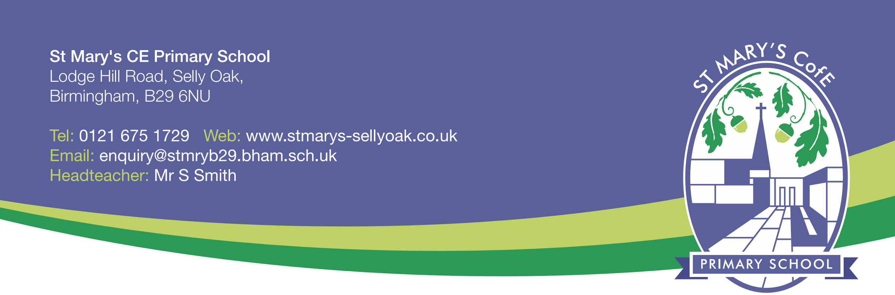

14th June 2018

Dear Parents,

School Funding – 2018 onwards

You may recall that I wrote to you last year highlighting the funding pressures that schools across the country are experiencing. Despite several months of national campaigns and media interest, the position remains largely unchanged with the costs of running a school now outstripping the level of funding received from government.

The issue has been exacerbated by a change to the way in which schools are funded. From April 2018 the total amount of money available for all schools in England has been redistributed in a different way to previous years. The result is that large urban cities such as Birmingham have lost a significant amount of funding under the new system and this has had an impact upon Birmingham schools.

At St Mary’s, we have had to manage a large reduction in our budget from this year and this is projected to continue for the coming years.

This has already had implications for how the school functions and to put this into context, I have listed some examples for you:
-The level of teaching assistant support has had to be reduced as the school could no longer afford to keep staffing levels as they were. By September 2018 we will have lost the equivalent of 80 hours learning support per week compared to the level we had in September 2016.
-Budgets for equipment and learning resources have been cut to a level where we can only replace rather than add to and develop.
-The subsidy we have historically provided for educational visits has had to be reduced.

In summary, a child in this school is at great risk of having an inferior quality of education compared to children in previous years because the school cannot fund the range of work that it used to.

Like thousands of other schools, we have had to absorb costs that the government have introduced and increased by stealth in recent years (such as Employer National Insurance contributions) without having the additional funds to cover these. Increased non-educational costs are continually draining money from schools and the government’s plans as they stand at the moment will render the current model of managing our school unsustainable in the long-term.

Continued…..

Continued…

You will know that many local services have been cut in recent years (particularly those that have supported vulnerable children and families). It is schools who have largely picked up the responsibility for providing these (again, with no additional funding) and we are no different.

You can help in the first instance by getting in touch with our local MP, Steve McCabe (who is fully aware of the situation local schools are facing) and explain your concerns from a parent’s perspective. You can also help by signing an online petition at www.schoolcuts.org.uk.

I wanted to share the current picture with you so you can understand why things are changing in school and will continue to do so if the situation does not improve. As before, I want to give you my commitment to communicate with all of you as frequently as I can regarding this and am, of course, available to discuss this with you if you would find it helpful.

Yours sincerely,

Mr S Smith
Headteacher

